NAME: ROZMIN ALI

REGISTRATION NUMBER: 21201260031

PAPER CODE: ECON05C11

INDIAN ECONOMY I

SEMESTER: 5

UNDERGRADUATE COURSE(B.SC)

PRESIDENCY UNIVERSITY

TOPIC:

PUBLIC EXPENDITURE ON PRIMARY, SECONDARY AND TERTIARY EDUCATION AND ITS IMPACT ON

GROWTH OF INDIA.

ABSTRACT:

The paper highlights how the expenditure on Primary, Secondary and Tertiary Education affects the GDP of India from the period of 1990-2020. This paper highlights that there is a positive relationship between the expenditure on Tertiary Education and GDP of India whereas there is a negative relationship between expenditure on Primary and Secondary education with GDP of India.

**Keywords*: Expenditure on Primary, Secondary and Tertiary Education, GDP of INDIA.***

1. INTRODUCTION

**Education** is the process of receiving or giving systematic instruction, especially at a school or university. (Source –Oxford Dictionary). We all need to be educated to get a better future and a bright life. Article 45 of the Directive Principles of the Constitution tells that all states have to provide ‘**free and compulsory education for all children until they complete the age of fourteen years**.’

There are basically three types of education:

1.**Formal education** – This refers to that type of education which is provided by intructors to pupils in a systematic and organised manner and it is goal oriented. For example – Classroom learning.

2. **Informal education** – This refers to that type of education which is not organised way of learning, for example, the basic learning we get from day-to-day life chores. It is not goal oriented.

3.**Nonformal education** is that form of learning which is not within the framework of formal learning.it does not lead to any certification. For example, this type of learning is provided to children going to swimming pool, chess club and so on.

**I**n today’s dog-eat-dog world, there is competition in every sphere of life where, one has to be educated than others to put herself or himself in a better place in life.

Once people are educated, they earn better and lead a healthy lifestyle. To maintain a good and sustainable life and eat good quality food, to create a good environment and to get rid of societal issues one has to educate himself or herself. To maintain a good standard of life, we need to have a good source of income, for which we need to be educated. Since everyone’s capability and capacity differs from others, there is skilled based income which is based on one’s degree or qualification for a particular post.

Usually, it is seen that if one’s degree or qualification is high, he or she will acquire a better post than others. It is extremely important to have basic education for every individual in the society so that it grows peacefully and helps to balance out things in a better manner.

1. LITERATURE REVIEW

In this section we have elaborated about the different findings of various papers. Education, being one of the most important sectors in the developing countries, we have seen the trend of the expenditure on EDUCATION in India and its impact on GDP of India.

Public expenditure in different education sectors and economic growth by **Ghosh Dastidar, Sayantan and Chatterji and Monojit (24 September 2014).** This paper shows that the expenditure in 3 sectors of Education is positively related to GDP of India from the time period 1951-2011. During this period the effect of positive relationship between the expenditure of three educational sectors with growth was negligible. The quality of educational system was pretty poor during that time.

Analysing the Linkages between Public Expenditure on Elementary Education, Educational Infrastructure and Outcomes in India by **Dr. Indira M** & **Nikita Pahwa (June 2020),** tells that government had spent almost half of its public educational expenditure on elementary sector, contributing to 4% of the country’s GDP. This paper also finds out that in 2007-2011, the elementary spending was high in Bihar and lowest Kerala. It had examined a state wise public spending on Elementary Education in 2007-2011.

Trends in Public Expenditure on Elementary Education in India by **Ambrish Dongre and Avani Kapur** (24 September, 2016)tells us that there was a slight increase in public expenditure in Primary Education in 18 states of India, except West Bengal in the time period 2011-12 and 2014-15. Public expenditure on education had contributed to a very small extent, almost to 1.56% of the GDP in 2011-12 and 1.38% of the GDP in 2014-15.

The Trends, Growth and Changing Patterns of Public Expenditure on Education in India by **Tasleem** (2017) highlights how both the Central and State government spent on educational sectors. There was a sharp rise in annual rate of public spending (around 13.4%) from 1990-91 to 2003-2004

Public Expenditure on the Education Sector in India by **Ashok Patil, S. V. Hanagodimath and Jai Prabhakar S. C.** (December 2022)paper depicts that there was huge differences in public spending on Education in various states of India, but the trend was constant from 1990-1991 to 2020-21.

**Ghosh Dastidar et al**., (2012) tells that the relationship between public expenditure and economic growth is large.

The composition of public expenditure and growth by **Devarajan et al.** (1996) used a data consisting of 43 developing countries to examine the relationship between public expenditure on education with growth of the country. This paper says that primary and tertiary education expenditure has no such effects on growth.

Role of Education in Education and growth of the society written by **Mathur and Mamgain** (2004) observes a higher education expenditure has the highest growth effects. Secondary education expenditure has more impact on the growth of a country than the primary education expenditure.

Public expenditure and school education in India with special references to Jharkhand by **DR. Renu Gupta** highlights the trend of public expenditure on Primary Education in India. It should contribute 6% of GDP of India.

A comparative study of the trends of public Expenditure on Education with special reference to school education paper by **Umendra Singh** (2019) paper tells us that the expenditure on Elementary education has increased over the years but in the terms of the GDP of the country, the expenditure is yet to reach its target (goal).

Trends and Growth of Public Expenditure on Education in India: An Analysis by **Dr. Sanjay Kumar (2020)** paper tells us that the rate at which the public expenditure on education is increasing at an alarming rate in India. It has done a state wise analysis of public expenditure on education where it was found that Manipur had the highest spending on education whereas Gujarat had the lowest spending on education. There was an upward rise in the trend of public expenditure on Education.

A Study on Growth of Higher Education Expenditure in India at Present by **A. Soundharya (2022)** highlights thatthe expenditure on education is increasing.

Public Expenditure on Higher Education in India by **Dr. Santinath Sarkar and Sushovan Koner (2017)** This paper tells us that the total government expenditure on education had increased by 5 times and expenditure on education as per percentage of GDP had increased by three times.

Public Spending in Higher Education in India: A Benefit Incidence Analysis by **Anuneeta Mitra (2015)** - This paper analyzes the time period in 2 different halves, one from 1990-2000 and the other from 2000-2010. It shows that Bihar has the highest growth rate of public expenditure on education.

1. OBJECTIVE

The objectives of this paper are the following:

a) to highlight the expenditure of primary, secondary and tertiary education in INDIA.

b) To depict the trend of such expenditures on GDP of INDIA.

1. METHODOLOGY

In order to proceed to the econometric analysis, we have regression on how GDP is affected by the expenditure on Primary, Secondary and Tertiary education. We have made bar graphs to analysis expenditures of Primary, Secondary and Tertiary education in India.

We have collected data of GDP (current US $) educational expenditure of 3 sectors (% of government expenditure) from the World Bank Website (<https://data.worldbank.org/> ).

1. DATA ANALYSIS

This is the regression of GDP (current US$) on expenditure of three different sectors of Education

1. **Total Government Educational Expenditure**

|  |
| --- |
| * reg gdpcurrentus TOTALGOVTEXPENDITURE |
|  |
| Source | SS df MS Number of obs = 19 |
| F(1, 17) = 4.60 |
| Model | 2.9828e+24 1 2.9828e+24 Prob > F = 0.0467 |
| Residual | 1.1021e+25 17 6.4827e+23 R-squared = 0.2130 |
| Adj R-squared = 0.1667 |
| Total | 1.4003e+25 18 7.7796e+23 Root MSE = 8.1e+11 |
|  |
|  |
| gdpcurrentus | Coef. Std. Err. t P>|t| [95% Conf. Interval] |
|  |
| TOTALGOVTEXPENDITURE | 1.90e+11 8.88e+10 2.15 0.047 3.12e+09 3.78e+11 |
| _cons | -1.19e+12 1.27e+12 -0.94 0.361 -3.88e+12 1.49e+12 |

Table1: Regression of GDP (current US$) on Total Government Expenditure in INDIA.

This table shows that if 1 % of Total Government Expenditure leads to 1.90e+11 increase in GDP of the country during 1990-2020. The p value is 0.047 which is statistically significant. Both the variables have a positive relationship among themselves (i.e. if one increases, then the other increases)

|  |
| --- |
| pwcorr gdpcurrentus TOTALGOVTEXP |
|  |
| | gdpcur~s TOTALG~P |
| gdpcurrentus | 1.0000 |
| TOTALGOVTEXP | 0.4615 1.0000 |

Table1.2: Correlation between GDP of India (current US $) and Total expenditure on Education.

The above data shows the correlation between GDP (CURRENT US$) and TOTAL EXPENDITURE ON EDUCATION (% of government expenditure on education) which is positive(i.e. 0.4615) indicating that as total expenditure on education increases, GDP of India increases and vice-versa. This is because the Total Expenditure on Education and GDP is positively related to each other.

The correlation between GDP(CURRENT US$) and GDP(CURRENT US$) and TOTAL EXPENDITURE ON EDUCATION (% of government expenditure on education ) and TOTAL EXPENDITURE ON EDUCATION (% of government expenditure on education) shows the value 1.0000. This is because the correlation between any variable and itself is always 1.

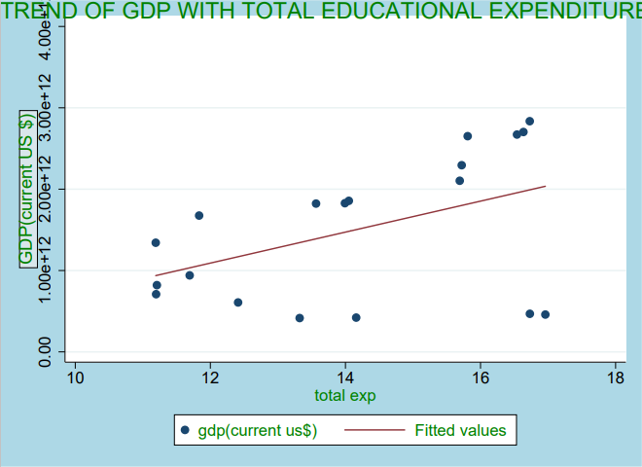Graph1: Trend of GDP (current US$) on Total government Educational Expenditure in India from 1990-2020.

This graph shows that there is positive relationship between GDP (current US$) and Total Government Expenditure on Education. Here as the government spending(G) increases, GDP(Y) of the country increases too. This is done by the government to provide a better educational platform, for example spending on building more schools and colleges in remote areas of INDIA which has poor educational facilities.

**b) EXPENDITURE ON PRIMARY EDUCATION**

|  |
| --- |
| * reg gdpcurrentus PRIMARYEXPENDITURE |
|  |
| Source | SS df MS Number of obs = 11 |
| F(1, 9) = 18.26 |
| Model | 2.2150e+24 1 2.2150e+24 Prob > F = 0.0021 |
| Residual | 1.0919e+24 9 1.2132e+23 R-squared = 0.6698 |
| Adj R-squared = 0.6331 |
| Total | 3.3068e+24 10 3.3068e+23 Root MSE = 3.5e+11 |
|  |
|  |
| gdpcurrentus | Coef. Std. Err. t P>|t| [95% Conf. Interval] |
| PRIMARYEXPENDITURE | -9.80e+10 2.29e+10 -4.27 0.002 -1.50e+11 -4.61e+10 |
| _cons | 4.21e+12 7.27e+11 5.79 0.000 2.57e+12 5.86e+12 |

Table2.1: Regression on GDP (current US $) with Expenditure on Primary Education.

This table shows that if 1 % of Primary Educational Expenditure leads to decrease in GDP of the country during 1990-2020. The p value is 0.002 which is statistically significant. Both the variables have a negative relationship among themselves (i.e if one increases, then the other decreases)

|  |
| --- |
| pwcorr gdpcurrentus PRIMARYEXP |
|  |
| | gdpcur~s PRIMAR~P |
| gdpcurrentus | 1.0000 |
| PRIMARYEXP | -0.8184 1.0000 |

Table2.2: Correlation between GDP of India (current US $) and expenditure on Primary Education.

The above data shows the correlation between GDP (CURRENT US$) and EXPENDITURE ON PRIMARY EDUCATION (% of government expenditure on education) which is negative (i.e.-0.8184). There was a decrease in expenditure on primary education during this time span, whereas GDP of India had increased due to other reasons. Government had focused on other sectors of Education other than Primary Education.

The correlation between GDP (CURRENT US$) and GDP(CURRENT US$) and PRIMARY EXPENDITURE ON EDUCATION (% of government expenditure on education ) and PRIMARY EXPENDITURE ON EDUCATION (% of government expenditure on education) shows the value 1.0000. This is because the correlation between any variable and itself is always 1.

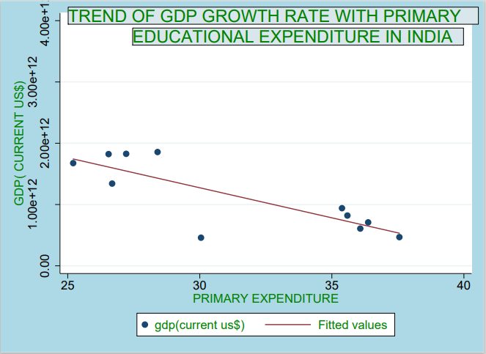

Graph2: Trend of GDP (current US $) with Expenditure on Primary Education(% of government expenditure)

This graph indicates a negative relationship between the Expenditure on Primary Education with GDP of India. In the given time period (1990-2020), the Expenditure on Primary education was less whereas the GDP had increased due to other factors.

**c)EXPENDITURE ON SECONDARY EDUCATION**

|  |
| --- |
| * reg gdpcurrentus SECONDARYEXP |
|  |
| Source | SS df MS Number of obs = 11 |
| F(1, 9) = 1.77 |
| Model | 5.4330e+23 1 5.4330e+23 Prob > F = 0.2162 |
| Residual | 2.7635e+24 9 3.0706e+23 R-squared = 0.1643 |
| * Adj R-squared = 0.0714 |
| Total | 3.3068e+24 10 3.3068e+23 Root MSE = 5.5e+11 |
|  |
|  |
| gdpcurrentus | Coef. Std. Err. t P>|t| [95% Conf. Interval] |
| SECONDARYEXP | -8.77e+10 6.60e+10 -1.33 0.216 -2.37e+11 6.15e+10 |
| _cons | 4.61e+12 2.62e+12 1.76 0.112 -1.31e+12 1.05e+13 |

Table3.1: Regression on GDP (current US $) with Expenditure on Secondary Education.

This table shows that if 1 % of Secondary Educational Expenditure leads to decrease in GDP of the country during 1990-2020. The p value is 0.216 which is statistically significant. Both the variables have a negative relationship among themselves (i.e if one increases, then the other decreases).

|  |
| --- |
| pwcorr gdpcurrentus SECONDARYEXP |
|  |
| | gdpcur~s SECOND~P |
| gdpcurrentus | 1.0000 |
| SECONDARYEXP | -0.4053 1.0000 |

Table3.2: Correlation between GDP of India (current US $) and expenditure on Secondary Education.

The above data shows the correlation between GDP (CURRENT US$) and EXPENDITURE ON SECONDARY EDUCATION (% of government expenditure on education) which is negative (i.e.-0.4053). There was a decrease in expenditure on secondary education during this time span, whereas GDP of India had increased due to other reasons. Government had focused on other sectors of Education other than secondary Education.

The correlation between GDP (CURRENT US$) and GDP(CURRENT US$) and SECONDARY EXPENDITURE ON EDUCATION (% of government expenditure on education ) and SECONDARY EXPENDITURE ON EDUCATION (% of government expenditure on education) shows the value 1.0000. This is because the correlation between any variable and itself is always 1

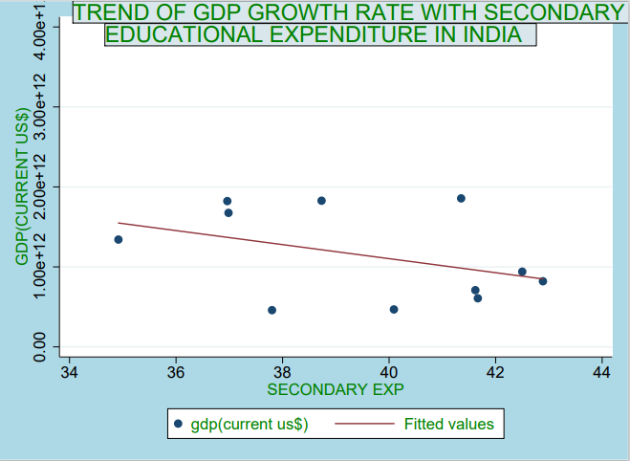Graph3: Trend of GDP (current US $) with Expenditure on Secondary Education (% of government expenditure).This graph indicates a negative relationship between the Expenditure on Secondary Education with GDP of India. In the given time period (1990-2020), the Expenditure on Secondary education was less whereas the GDP had increased due to other factors.

**d) EXPENDITURE ON TERTIARY EDUCATION**

|  |
| --- |
| * reg gdpcurrentus TERTIARYEXP |
|  |
| Source | SS df MS Number of obs = 11 |
| F(1, 9) = 27.54 |
| Model | 2.4924e+24 1 2.4924e+24 Prob > F = 0.0005 |
| Residual | 8.1438e+23 9 9.0486e+22 R-squared = 0.7537 |
| Adj R-squared = 0.7264 |
| Total | 3.3068e+24 10 3.3068e+23 Root MSE = 3.0e+11 |
|  |
|  |
| gdpcurrentus | Coef. Std. Err. t P>|t| [95% Conf. Interval] |
| TERTIARYEXP | 6.56e+10 1.25e+10 5.25 0.001 3.73e+10 9.38e+10 |
| _cons | -5.64e+11 3.37e+11 -1.67 0.128 -1.33e+12 1.98e+11 |

Table4: Regression on GDP (current US$) with Expenditure on Tertiary Education This table shows that 1% increase in Tertiary Expenditure, there is 6.56e+10 increase in GDP of the country. The p value is 0.001 which is statistically significant. Both the given variables have a positive relation among themselves. (as expenditure on tertiary education increases, GDP of a country increases)

|  |
| --- |
| pwcorr gdpcurrentus TERTIARYEXP |
|  |
| | gdpcur~s TERTIA~P |
| gdpcurrentus | 1.0000 |
| TERTIARYEXP | 0.8682 1.0000 |

Table4.2: Correlation between GDP of India (current US $) and Total expenditure on Education.

The above data shows the correlation between GDP (CURRENT US$) and EXPENDITURE ON TERTIARY EDUCATION (% of government expenditure on education) which is positive (i.e. 0.8682) indicating that as expenditure on Tertiary education increases, GDP of India increases and vice-versa. This is because expenditure on Tertiary education and GDP is positively related to each other in the given period of time.

The correlation between GDP(CURRENT US$) and GDP(CURRENT US$) and EXPENDITURE ON TERTIARY EDUCATION (% of government expenditure on education ) and EXPENDITURE ON TERTIARY EDUCATION (% of government expenditure on education) shows the value 1.0000. This is because the correlation between any variable and itself is always 1.

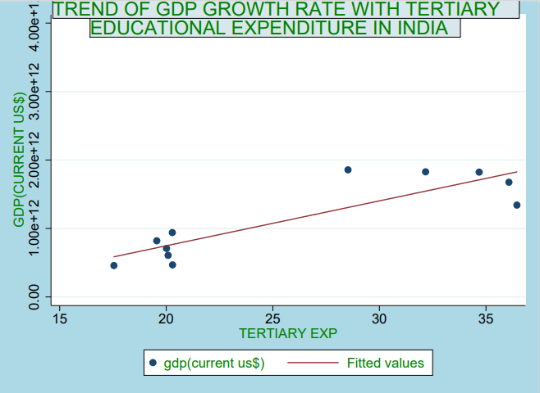

Graph4: Trend of GDP growth rate with Tertiary Educational Expenditure in India from 1990-2020.

The above graph shows a positive trend in GDP and Expenditure on Tertiary education. The reason behind this is as the Government spending increases, colleges and universities providing higher education, is capable of providing a good placement to students. A high amount of fund is received by colleges and universities from the Government and given to the researchers as stipend and scholarship. Students come from different countries to receive a PHD degree as the cost of publishing thesis is less in India compared to other countries. To accommodate so many students, the government spending is high.

There are 4 graphs showing the expenditure in three different sectors of Education in INIDA from 1990-2020.

* **TOTAL GOVERNMENT EXPENDITURE:**

Graph1.1: Total Expenditure on EDUCATION from the time period of 1990-2020.

This graph shows that the expenditure was highest in the year of 1999-2000 and 2018-2020 in INDIA.

* **PRIMARY EDUCATION:**

Graph2.1: Expenditure on Primary Education from the time period of 1990-2020.

In this graph we are seeing that the primary educational expenditure is highest in 2000 and lowest in 2010.

* **SECONDARY EDUCATION:**

Graph3.1: The Expenditure on Secondary Education from the time period of 1990-2020.

This shows that the expenditure on Secondary education was high during the period of 2003-2006 in INDIA.

* **TERTIARY EDUCATION:**

Graph4.1: Expenditure on Tertiary Education from 1990-2020 in India.

The above graphs depicts that the expenditure on Tertiary education is high during 2009-2010 and the lowest in 1999 in India.

1. FINDINGS

There is positive relationship between Total expenditure and GDP, tertiary sector educational expenditure has a positive impact on GDP from the time period 1990-2020.

In India, 1990 onwards there was Globalisation due to which graduates got innumerable job opportunities in all sectors. The spending by government was high to provide a platform for better educational facilities. More colleges and universities were built along with more research laboratories. More and more graduates were getting a good placement in different sectors.

In INDIA, the Primary and Secondary Educational Expenditure is negatively related to GDP from 1990-2020, as the Government had focused to increase the GDP of the country, on other sectors, instead of these two sectors. There was a decline in the expenditure of Primary Education in the given time period whereas the expenditure of secondary education was almost constant from the given period of time.

1. POLICIES TAKEN BY THE GOVERNMENT

TO PROVIDE BETTER EDUCATIONAL FACILITIES.

1. It is important for the government to build more schools and colleges in every remote part of India.

2. Schools should provide free and compulsory education to children below 14 years- **The** **Right to Education** **Act** was passed in 2009.

3. **National Scheme of Incentive to Girls for Secondary Education (NSIGSE)** – This is one of the policies which has enhanced Girl’s education in Secondary level in India. In this scheme Rs 3000/- has been deposited in the name of the student so that she can withdraw it after her schooling is over.

4. Irrespective of which reserved category a student belongs to all should get an opportunity to get educated.

5. **Rani Laxmibai Atma Raksha Prashikshan-** This scheme tells us about the safety of every girl in school.

6.**Beti Bachao Beti Padhao** **Abhiyan** is one of the schemes started from 15 January, 2015 which provides a platform for every Girl child.

7. **Sarva Shiksha Abhiyan (SSA)** was launched in 2001, to promote the educational facilities to children universally.

8.**Pradhan Mantri Poshan Shakti Nirman**, launched in 1995 to provide free food to children studying in government schools. This was done to improve the quality of food provided to pupils. It is also called **Mid-Day Meal Scheme.**

**9.Rastriya Madhyamik Shiksha Abhiyan** was launched in 2009, aiming at providing secondary education to children.

**10.National Achievement Service (NAS)** shows the outcome of subjective learning of students, studying in classes from 3,5,8 and 10.

**11.National Education Policy,** launched in 2020, is improve the education system

**12.National Means-cum-Merit Scholarship Scheme (NNMS),** launched in 2008, provides financial aid to students coming from different economic backgrounds.

1. CONCLUSION

Education is considered to be one of the basic needs of everyone’s life.

There are various benefits of a good education system in a country. A well-developed country has a good educational infrastructure compared to an underdeveloped one. It is via an educational degree that differentiates one from the other in this competitive world. It gives us innumerable job opportunities. Educating oneself is extremely important.

As the economy grows it is important for the citizens to be well educated. To provide a better infrastructure in educational sector, Government expenditure is usually high, mainly in Tertiary Education. There are policies which tells us how the Indian Government is trying its level best to improve the quality of Education in INDIA.

This paper has found out a positive relationship between Total Expenditure in Education with GDP of the country. Primary and Secondary education expenditure is negatively related to GDP for the given period of time (1990-2020).

1. **DATA**

**(Source world bank data (**<https://data.worldbank.org/>**))**

|  |  |  |  |  |  |
| --- | --- | --- | --- | --- | --- |
| YEARS | gdp(current us$) | TOTAL GOVT | PRIMARY | SECONDARY | TERTIARY |
| 1990 | 320979026420.04 | EXPENDITURE | EXPENDITURE | EXPENDITURE | EXPENDITURE |
| 1991 | 270105341879.23 |  |  |  |  |
| 1992 | 288208066640.58 |  |  |  |  |
| 1993 | 279295644530.09 |  |  |  |  |
| 1994 | 327275583539.56 |  |  |  |  |
| 1995 | 360281907854.99 |  |  |  |  |
| 1996 | 392896860670.89 |  |  |  |  |
| 1997 | 415867567334.19 | 13.32223034 |  |  |  |
| 1998 | 421351318896.87 | 14.15927029 |  |  |  |
| 1999 | 458820417337.81 | 16.95982933 | 30.04633 | 37.80222 | 17.54497 |
| 2000 | 468394937262.37 | 16.73051071 | 37.55736 | 40.09062 | 20.29511 |
| 2001 | 485441014538.64 |  |  |  |  |
| 2002 | 514937948870.08 |  |  |  |  |
| 2003 | 607699285433.87 | 12.41079998 | 36.07693 | 41.66589 | 20.08727 |
| 2004 | 709148514804.66 | 11.19686031 | 36.37518 | 41.61946 | 20.01232 |
| 2005 | 820381595512.90 | 11.20845985 | 35.58925 | 42.88835 | 19.55496 |
| 2006 | 940259888792.14 | 11.69371033 | 35.38399 | 42.50008 | 20.28408 |
| 2007 | 1216736448906.29 |  |  |  |  |
| 2008 | 1198895147694.77 |  |  |  |  |
| 2009 | 1341888016988.57 | 11.19120026 | 26.68135 | 34.91827 | 36.45114 |
| 2010 | 1675615502766.20 | 11.83368015 | 25.20659 | 36.9852 | 36.07652 |
| 2011 | 1823051829894.55 | 13.56490993 | 26.54745 | 36.96254 | 34.68074 |
| 2012 | 1827637579584.79 | 13.99211979 | 27.21284 | 38.7325 | 32.1669 |
| 2013 | 1856721494834.64 | 14.05018044 | 28.40116 | 41.35294 | 28.52687 |
| 2014 | 2039126469963.35 |  |  |  |  |
| 2015 | 2103588347241.77 | 15.69221973 |  |  |  |
| 2016 | 2294796889945.04 | 15.7215004 |  |  |  |
| 2017 | 2651474263257.15 | 15.80976963 |  |  |  |
| 2018 | 2702929639861.50 | 16.63537979 |  |  |  |
| 2019 | 2835606242052.48 | 16.72864914 |  |  |  |
| 2020 | 2671595389575.70 | 16.54015923 |  |  |  |

1. REFERENCES:

* **Ghosh Dastidar, Sayantan and Chatterji and Monojit “**Public expenditure in different education sectors and economic growth**”(24 September 2014).**
* **Dr. Indira M** & **Nikita Pahwa (June 2020) “**Analysing the Linkages between Public Expenditure on Elementary Education, Educational Infrastructure and Outcomes in India “
* **Ambrish Dongre and Avani Kapur** (24 September, 2016) “Trends in Public Expenditure on Elementary Education in India”
* **Tasleem** (2017) “The Trends, Growth and Changing Patterns of Public Expenditure on Education in India”
* **Ashok Patil, S. V. Hanagodimath and Jai Prabhakar S. C.** (December 2022) “Public Expenditure on the Education Sector in India”
* **DR. Renu Gupta** “Public expenditure and school education in India with special references to Jharkhand”
* **Umendra Singh** (2019) “A comparative study of the trends of public Expenditure on Education with special reference to school education paper “
* **Dr. Sanjay Kumar (2020)** “Trends and Growth of Public Expenditure on Education in India: An Analysis “
* **A. Soundharya (2022)** “A Study on Growth of Higher Education Expenditure in India at Present “
* **10.Dr. Santinath Sarkar and Sushovan Koner (2017)** “Public Expenditure on Higher Education in India”
* **11. Anuneeta Mitra (2015) “**Public Spending in Higher Education in India: A Benefit Incidence Analysis”
* **Devarajan et al**(1996) “The composition of public expenditure and growth”
* **Mathur and Mamgain** (2004) “Role of Education in Education and growth of the society”.
* The data has been collected from The World Bank Data (<https://data.worldbank.org/>)